My Guide
A must have ☺
2021-2022

2021-2022

Hello,
Welcome to Montpellier SupAgro for this new school year.
This guide, created by foreign students from Montpellier SupAgro, attempts to answer some important questions asked by students newly admitted to courses at the institution. It is intended for all SupAgro students, but more particularly for foreign and international students. It is built in a very simple way to be accessible to everyone.
We were inspired by our own experiences and the questions asked by foreign students arriving for their first year of study in France and in particular in Montpellier SupAgro.
The information comes from personal acquaintances, websites and the guide produced by the Accueil des Étudiants Étrangers group led by Mrs Gisèle André from SupAgro/IRC. These may change over time.
Depending on the training you follow, you will be on the IRC (Institute of Hot Regions) campus or on the La Gaillarde campus. These campuses are 5 km away. The student residences are located on the La Gaillarde campus.
The addresses of the 2 campuses:
- Institute of Hot Regions: 1101 Avenue Agropolis in Montpellier-France;
- La Gaillarde: 2 place Pierre Viala, 34060 Montpellier-France.

CONTENT
1 ADMINISTRATION IN FRANCE 6
1.1 RESIDENCE PERMIT: FRENCH Office for IMMIGRATION AND INTEGRATION (OFII) 6
1.2 CROUS: "STUDENT LIFE" CONTRIBUTION 6
1.3 Health : Health Insurance. 7
1.3.1 How to obtain social security? 7
1.3.2 Additional cover 9
1.4 Housing subsidies: THE FAMILY ALLOWANCE FUND (CAF) 10
1.4.1 How to obtain the APL? 10
1.4.2 When? 10
1.4.3 Tips & Advice 10
1.4.4 Where? 10
1.5 THE BANK 11
1.5.1 Normal bank 11
1.5.2 Online Banking 11
1.6 INSURANCES 12
1.6.1 Housing insurance 12
1.6.2 Civil liability insurance 12
2 LIFE IN MONTPELLIER 13
2.1 Telephone networks 13
2.2 Transports 13
2.2.1 Public transport : Transport de l’Agglomération montpelliéraine (TAM) 13
2.2.2 Cycling 14
2.2.3 Organized carpooling 14
2.2.4 The trips you are likely to make throughout the year 14
2.3 Food 16
2.4 Hobbies 16
2.4.1 Discount cards 17
3 STUDENT LIFE 19
3.1 FEDERATION OF STUDENT ASSOCIATIONS AND ELECTED STUDENTS 19
3.2 THE STUDENTS' OFFICE 19
3.3 THE ARTS OFFICE 19
3.4 THE SPORTS OFFICE 20
3.5 Ingénieurs Sans Frontières (ISF) 20
3.6 JUNIOR ENTREPRISE OF MONTPELLIER SUPAGRO 20
4 PRACTICAL ADVICE 21
4.1 FOR NON-FOOD PURCHASES 21
4.2 ASSISTANCE TO THE PERSON 21
4.2.1 Free psychological consultation - La Gaillarde 21
4.2.2 Training: PSC1 21
4.2.3 Social Services 22
4.3 SITES THAT MAY BE USEFUL TO YOU 23
4.3.1 In case of emergency, you must call: 23

forewords
Before you arrive, you will need to:
- Book student accommodation
- Open a bank account
- Make your home and liability insurance.
- Establish your housing allowance file (CAF)
- Pay the Contribution to Student Life and Campus (CVEC) at Crous
When you arrive, you will need to:
- Make the OFII file (for newcomers to France)
- Register for health insurance on etudiant-etranger.ameli.fr
- Find a means of transport (bus with subscription, bicycle...) and draw up your travel card
- Shopping for your installation,
- Get a phone number
- Make your administrative registration with your training assistant
Always keep with you:
- Proof of identity (passport, residence card, identity card, student card, etc.),
- Proof of accommodation (accommodation certificate, invoice),
- RIB, credit card and/or cheque book,
- School certificate.
- Proof of your social security and mutual certificate

- ADMINISTRATION IN FRANCE
  - RESIDENCE PERMIT: FRENCH Office for IMMIGRATION AND INTEGRATION (OFII)
To be done during the first 3 months following your arrival in France.
Since February 18, 2019, the validation procedures for Long Stay Visas Valid Residence Permit (VLS-TS) have been modified and will only be carried out on the Internet at the following address: https://administration-etrangers-en-france.interieur.gouv.fr
To do this you will need:
- A valid email address,
- Information from your visa,
- To communicate your date of entry into France,
- Your address of residence in France,
- From your payment card to pay online the fee for issuing a residence permit (see other payment methods on the portal)
You will receive a certificate to be printed and attached to your passport, attesting to the validity of your EPV-TS. This residence permit is valid for one year. Two months before the end of the validity of your visa, you will have to apply for the renewal of your residence permit.
If you have not completed this procedure within 3 months, you will no longer be a legal resident on French territory and, consequently, you will not be able to cross the Schengen area border again.
If you have any further concerns about these procedures, you can contact SupAgro's International Student Service at IRC, but it is up to you to do the procedures online at ☺
Cost in 2021: 50 € (stamp that you can buy online at https://timbres.impots.gouv.fr/ or in a tobacco shop).
  - CROUS: "STUDENT LIFE" CONTRIBUTION
Since the beginning of the 2018 academic year in France, before enrolling in a higher education institution, you must provide a certificate of payment of the Student Life and Campus Contribution (CVEC) that you can obtain from 1 July.
The CVEC is collected by the Crous and amounts to 92€ for the year 2021-2022.
You are exempt from paying the CVEC if you are :
- Student Scholar (Scholarship on social criteria)
- Refugee student
- Beneficiaries of subsidiary protection
- Registered as an asylum seeker and that you have the right to remain on French territory
- Student enrolled in an Erasmus programme
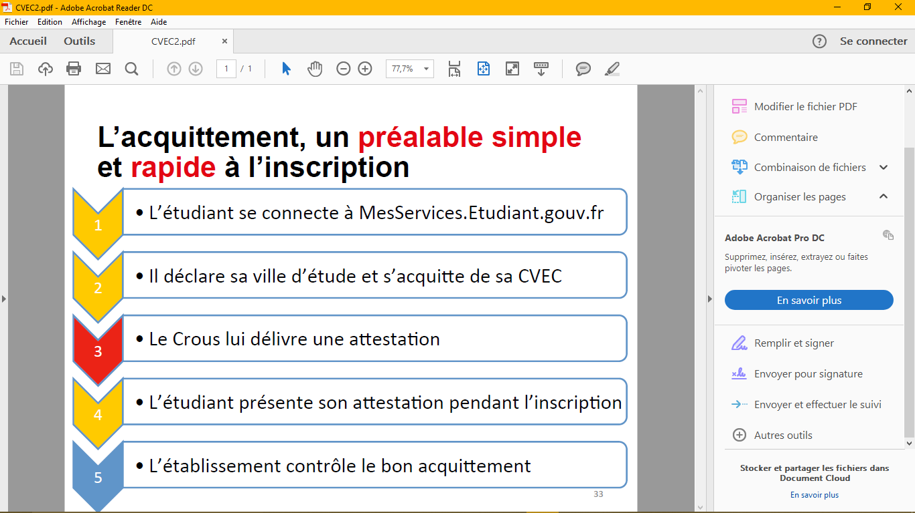
  - Health : Health Insurance.
Health care costs are expensive in France. The consultation with a general practitioner will cost you about 25 €, dental or ophthalmic care has high costs ☹
But fortunately the Social Security is there ☺ to reimburse you 70% (in general) of the fees!
To benefit from the coverage of your care in France, you must prove that you are a stable and regular resident.
Proof of stable residence may be any document attesting to the student's status (e.g., a certificate of attendance, a copy of the student card, etc.).
    - How to obtain social security?
To obtain your Social Security in France, you will first have to register on the website: www.etudiant-etranger.ameli.fr
You must register once you arrive in France, and after payment of the "student life" fee to the CROUS and your final registration in Montpellier SupAgro.
You will be asked to attach the following supporting documents :
- Of your identity (national identity card, passport ...),
- From your registration at a higher education institution for the academic year concerned, in order to attest to your student status,
- Your bank account statement (RIB) which will allow you to receive your repayments
- A civil status document necessary for the creation of your registration number. The civil status documents accepted are:
  - A complete copy of the birth certificate,
  - a birth certificate with filiation (or any document issued by a consulate) ,.
- A regular residence permit must be presented
The proof of the regularity of the stay is not the same depending on the country of which you are a national.
Keep the temporary social security number that will be automatically assigned by the site and print your certificate of entitled benefits (which allows you to go to the doctor is to be reimbursed)

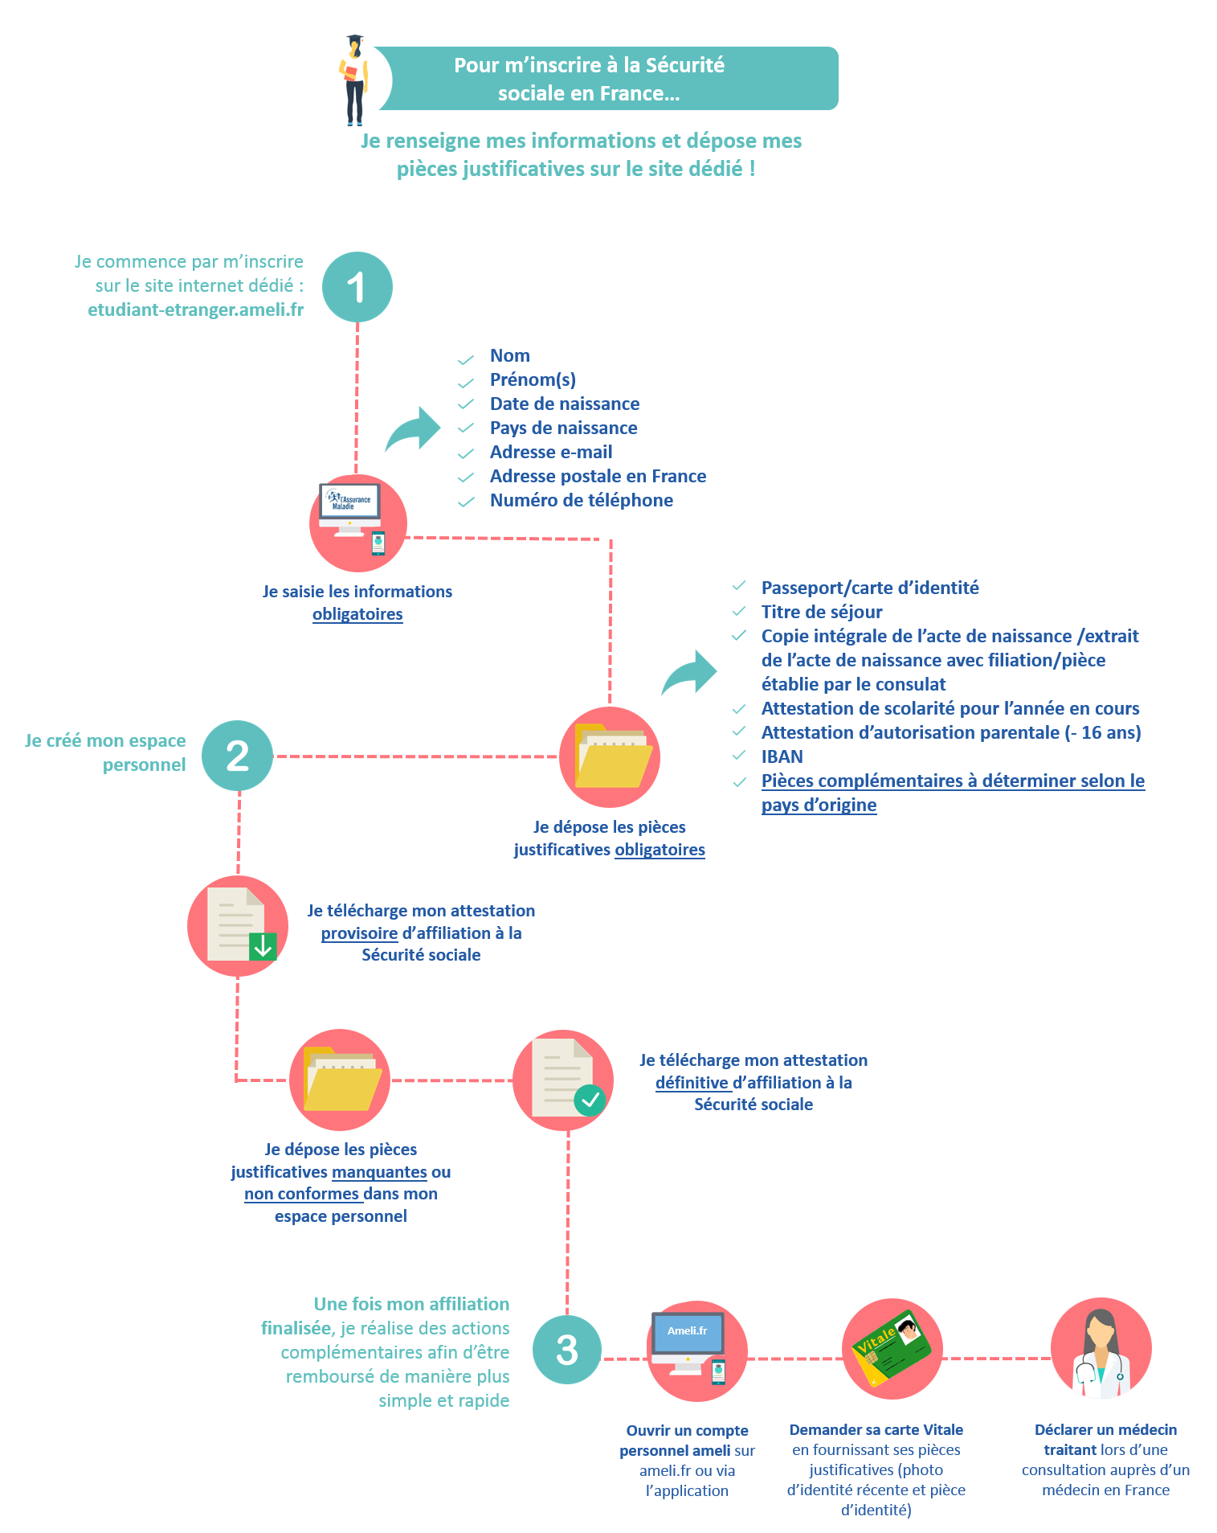

    - Additional cover
If you go to the doctor, the Social Security will reimburse you 70% of the expenses, the rest will be at your expense.
To complete the social security reimbursements, you can join the complementary health insurance of your choice. Ask a student mutual insurance company (HEYME) or another complementary organisation for information on the level of services you want: it varies according to the contracts and your health needs.
These organisms offer you several types of Packages for your complementary health insurance and repatriation assistance in case of illness during a trip or internship outside France during the academic year. Feel free to check their website for more information.
To supplement the Social Security reimbursements, you can also benefit, under certain conditions, from a totally free complementary health insurance: the complementary universal health coverage (CMU-C, couverture maladie universelle complémentaire), provided you meet the conditions of resources.
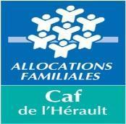
  - Housing subsidies: THE FAMILY ALLOWANCE FUND (CAF)
CAF helps you pay portion of your rent. It pays you a Personalized Housing Assistance (APL) that can go from 50€-220€ depending on your situation. ☺
    - How to obtain the APL?
As soon as you have the confirmation of your accommodation booking, go to the caf website: www.caf.fr. Register online following the instructions. Then you will be asked for administrative documents that you can send either from your CAF personal space with your identifiers, by mail or directly to the CAF de l'Hérault service. Possible to have an explanatory leaflet in French and English at the residences' office. ☺
    - When?
ASAP to collect your APL.
If the file is not complete your file will not be accepted ☹.
The first payment can be a little long (after 3 months) ☹. The first month is not included in the calculation.
    - Tips & Advice
Open your CAF personal account often to keep you informed of the progress of your case and your right to APL. If you don't get an answer for 2 months, try to visit them or contact them from your personal space or by phone.
    - Where?
Postal addresses: 139 avenue de Lodève, 34943 MONTPELLIER CEDEX 9
Bus line 10 (direction Celleneuve): Marie Curie stop, La CAF is in front of you ☺
OR
Bus line 15 (direction Celleneuve): Tonnelles Stop, then take Avenue de Lodève (600 meters).

  - THE BANK
    - Normal bank
In France the most well known banks are: LCL, BNP Paribas, Crédit Agricole, Société Générale, La Banque Postale, Banque populaire... They have the same roles. However, some are more interesting for students than others. Open your account as soon as you obtain your school certificate and your accommodation certificate.
To open an account, you must:
- School certificate,
- Proof of identity (passport with visa or residence card),
- Certificate of accommodation,
- An amount greater than or equal to 15€ to deposit into your account.
- Your bank will give you: a credit card, a RIB (bank account number or RIB), a cheque book according to your contract as soon as possible.
    - Online Banking
Online banks can offer better services, lower banking fees, more remunerative savings products or simply the possibility of having student credit.
The opening conditions for a student: There are huge differences from one bank to another.
After several searches and verifications, Monabanq is the only online bank that does not require entry requirements.
    - Tips & Advice
There are partnerships between the Montpellier SupAgro Student Associations and many banks that allow you to benefit from free banking fees for three years. These are BNP Paribas and Société Générale.
The LCL which is a bank that also offers many offers for students and bank fees are low. La Banque Postale also offers fairly reasonable quarterly bank fees (3.70 euros).
- Société Générale: Agence avenue d'Assas - 20 mn by foot from the residence. FREE CARD - WITHDRAWALS - CLOSING THE ACCOUNT AND TRANSFERING SUMMENTS FROM ONE ACCOUNT TO THE OTHER - Home and Civil Insurance, INTERNATIONAL CARD OPTION : 2euros/month practical during the internships (on request)
- BNP Paribas is located near Place de la Comédie, tram line 1. Address: 8 rue Maguelone, 34060 Montpellier
- LCL is located opposite the Carrefour-City; take the bus line 15 direction Odysseum and get off at Henri Dunant stop; a stop after Saint Eloi; the Carrefour-City is in front of you
- La Banque Postale is next to Le Lidl which is 10 minutes walk from the residences (it is better to go there around 9am).
If you want information about other banks, you can go to their websites. It should be noted that there are several agencies in the city and you will choose the one that is most accessible to you.
  - INSURANCES
Everyone must have an insurance in France!
    - Housing insurance
Home insurance covers you against fire, bad weather, theft... This is a document required for any accommodation reservation or at the latest one week after your entry into the accommodation for the Student Residences of Montpellier SupAgro.
How to get Home Insurance? You can subscribe it with the insurance services of MAE, MAIF or your bank (LCL, BNP Paribas, Société Générale, Crédit Agricole...) and even with the student mutual insurance company.
How much? About 60€/year and it depends on the services offered, the size of your accommodation....
Advice: ask your bank, you can take advantage of student/youth offers at an advantageous price.
    - Civil liability insurance
It is also compulsory and is part of SupAgro's registration file. It covers you against the damage you have caused to third parties. Civil liability insurance can be taken out with your bank, in insurance agencies or in the same package as your complementary health insurance with your mutual insurance company (HEYME).
Just like the with normal banks, you can also subscribe to an insurance online. For example, ADH proposes lower rates compared to banks. Housing insurance and civil responsibility can cost you as little as 30 euros.
You can visit their website by clicking on the link down below:
https://www.assurances-etudiants.com/fr/5311-assurance-logement-etudiant-tarifs-garanties.html
- Life in Montpellier
  - Telephone networks
There are several mobile networks, the main ones are SFR, whose sub-branch is the Red series, ORANGE with Sosh and BOUYGUES, whose sub-branch is B & You and Free.
You can take packages with contract or without... for more information, you can look at the various websites of these networks
Tips : when you arrive, you can get a card from :
Ortel ,Lebara, ou lyca
These subscription cards are sold in Tobacco, Taxiphone, telecommunication shops. These are uncomplicated chips, easy to use and affordable for international calls
  - Transports
    - Public transport : Transport de l’Agglomération montpelliéraine (TAM)
In Montpellier the public transport network is very developed. There are more than 33 bus lines and 4 tram lines. Most students take these public transport.
One trip costs 1.60 € (1 hour with free connection on another bus line and / or Tram)
How to subscribe: You can subscribe online (on http://commercial.tam-voyages.com/ ) or by going to a TAM agency (The nearest is to Saint-Roch station).
• Line 6 (direction PAS DU LOUP). Stop Saint-Roch station.
• Tram line 1-2-3 or 4 🡪Saint Roch station stop
For under 26 years old: The subscription for the month is 29.12 € to recharge each month and the first month 34 € because the card costs you 5 €. The subscription to the year costs 196 € (with 5 € for the card)
You can take an annual subscription payable by direct debit of about 29.12 € / month for 7 months.
For over 26 years old: Monthly subscription costs € 50 to recharge each month
Subscription to the year costs 450 € (with possibility to pay 52 € / month for 9 months)
To make a TAM subscription card you need:
- An ID
- Housing certificate
- Photograph
- A certificate of registration
- Bank details for automatic debits
NB: Do not forget to take in the premises of the TAM a map of the TAM network and the bus and tram schedules that interest you. You can also find them live on the TAM application available on Playstore and Appstore or on the website www.tam-voyages.com
    - Cycling
The bike will be convenient in Montpellier. Buses and trams do not run 24/24. They do not go everywhere, the bike if (or almost)
How to buy a bike.
- Buy a second-hand bike for around €40 at the flea market 🡺 Every Sunday morning in Mosson (tram 1/3, Mosson stop) or from former students who leave the city to go on mobility or at the end of their training.
- If you want to buy a new bike, you can go to DECATHLON (tram 1, stop Odysseum)
- Rent a Velomagg at the TAM: For 10€, if you already have the annual TAM subscription (Velomagg extension). Self-service Velomagg rentals (0.50 € per hour), are to be paid in addition, by monthly direct debit. You take a Vélomagg which is located in the Vélomagg stations (there is one opposite the Gaillarde) for less than 1 hour otherwise you pay 0.50€/h.
For more information, inquire with the other students or TAM!
    - Organized carpooling
If you live in one of the SupAgro residences (or near it) and are in training at the IRC, check with your classmates if they do not carpool for the IRC. Very often, students with cars offer places in exchange for a sum to be defined.
    - The trips you are likely to make throughout the year
- From the airport to SupAgro residences
Once you get out of the airport, you have to go to the nearest bus stop (La Navette) (do not hesitate to ask at the information points to find out where it is).
It is a Hérault Transport shuttle bus, another transport company in the region, which connects Montpellier-Mediterranean Airport to the city of Montpellier.
This shuttle takes you to the Place de l'Europe, a tram stop of TRAM 1, you have to take it in the direction of Mosson and stop at the Saint-Roch station. Once you arrive at the station, you have to go to the Observatory stop, at this stop you have to take the bus 6 direction Euromédecine.
Shuttle 120 (Hérault Transport) → Place de l'Europe: Tram 1 (Blue with birds) Direction Mosson → Stop at Gare Saint-Roch → Go to the other tram stop (on the other side of the park) and then get on at the next tram stop, the "Observatoire" stop → Bus 6 - Direction EUROMEDECINE → Stop at "Pierre Viala" → Go to "Quartiers Étudiants SupAgro" : You have arrived!
Airport Shuttle Schedules:
https://www.montpellier.aeroport.fr/fileadmin/PASSAGERS/ACCES/TRANSPORTS_PUBLICS/horaires-navette-airport-montpellier-mediterranee-ete-2018.pdf
- From Montpellier Saint Roch station to SupAgro residences
You have to take the Downtown exit, to be sure you are in the right place, you should see the Casino City from the station, you will see at your exit 2 tram lines on each side, go left at the Observatory stop, located one stop after the one you see on the left. Take bus 6 and stop at the "Pierre Viala" stop. Walk two minutes to students Residences.
- Trips from and to both campuses
- Go from SupAgro residences to IRC
To go to the IRC, you take :
- Bus line 15, direction Odysseum
- Louis Ravaz stop
- Get off at Saint Eloi:
Cross the main avenue (two lanes), go to the tram stop and take tram 1 direction Mosson. Get off at the Université des Sciences et Lettres Stop (1 stop away)
- Bus line 6, direction Euromédecine
- Pierre Viala stop
- Get off at Château d’Ô
Cross the tram line and take tram line 1 at the Château d´Ô stop towards Odysseum. Get off at the Université des Sciences et Lettres stop (3rd stop).

Then take:
- Shuttle A or B or bus line 22 direction Jacou.
- Get off at the Agropolis stop
Depending on the bus driver, IRC is in front of you or on your right when getting off the bus ☺
- From IRC to SupAgro Residence
Shuttle bus A or B or Bus line 22 direction Université des Sciences et Lettres
- Get off at the stop Université des Sciences et Lettres
- Take tram 1 direction Odysseum / Take tram 1 direction Mosson
- Get off at Saint-Eloi / Get off at Château d’ô
- Take bus line 15 direction Sabines / Take bus line 6 direction Pas du loup
- Louis Ravaz stop / Pierre Viala stop
You can also go there by foot or by bike!!!!!!!
By walking: Follow the bus path (La Navette and la Ronde), you go about 40 minutes to 1 hour (it depends on your pace).
By bike: Follow the bus path, you can do it in 20-25 min!
  - Food
To shop near residences:
- Épicerie, is about 10 minutes walk from the SupAgro residences
Address: 9 place Corot, 34000 Montpellier
The itineraries from the residences:
- Head west on Rue Croix de las Cazes toward Rue Enclos des Brosses (260 m)
- Turn right on Rue de Cante Gril (190 m)
- Turn left on Rue Paul Rimbaud (280 m)
- Turn left on Place Corot (LIDL is on your right).
- Géant Casino, supermarket 30 minutes walk from the residences (after LIDL), you can also take the rounds - stop at "Tonnelles".
Address: 129 Avenue De Lodève - 34000 Montpellier
The supermarkets: Auchan, E-Leclerc, crossroads, Leader-Price... are further away, at Géant you can find your white BLOUSE essential for practical work!
You can also get fresh produce and food every Saturday morning from 7am to 1pm at the Arceaux market, 10 minutes walk from the residences. Follow Avenue Ecole d'Agriculture Gabriel Buchet from the Pierre Viala bus stop.
  - Hobbies
So now you have to ask yourself if you can not get discounted rates for leisure and sports! Well, you can !
    - Discount cards
- The Yoot card for the under 31 year old (9 €) :
This card costs 9 euros and is valid for one year from September. It gives you access to movie tickets for € 3.90 at low-budget cinemas: Diagonal cinema, Utopia, and Nestor Burma. But you can also buy online (http://www.yoot.fr ) tickets for shows and concerts at prices ranging from 5 to 10 euros. You will also have the chance to meet artists, visit theaters, be invited to premieres of films…
To get it, you just need:
- To provide you with a proof of your student status for the year 2019/2020, a passport photo and 9 €
- With these pieces you have to go to one of the many kiosks of the Yoot culture pass. There is one in the SupAgro cafeteria on Thursdays from 12pm to 2pm (La Gaillarde). You can also register online via the "www.messervices.étudiant.gouv.fr" portal.
- The card pass’ métropole (0€)
This free card allows you to get discounts in the fields of sport, culture and leisure (see here http://www.montpellier3m.fr/passmetropole).
To get it, you just need:
- to bring an identity card, a proof of residence less than three months old and a photo
- with these rooms you have to move to a local house. There is a 50 Place Zeus (Tram Line 1 stop "Léon Blum" - Tram Lines 2 and 4 stop "Place de l'Europe"/ Bus Lines 9, 37 and 120 stop "Place de l'Europe", and Line 14 stop "Léon Blum")
- The tutti'pass card for children under 30 years old (20€)
This 20 euros card allows you to see 4 concerts or performances at the Opéra Comédie to choose from among the subscription shows. You can buy as many cards as you want during the year.
Once you have purchased the card, you only need to present yourself with the card at the opera ticket office one hour in advance to get a ticket. Within the limit of available places!
To get it, you just need :
- to Fill in the information on the following link: http://www.opera-orchestre-montpellier.fr/formulaire/fiche-de-renseignements-jeunes
- To bring you the supporting documents they ask you and the 20€
- To pick up the card at the comedy opera with these pieces in hand
- The Montpellier sports card (5€):
This card, which costs 5 euros, will allow you to access more than 50 disciplines supervised by the City's sports educators: team sports, gymnastics, weight training, judo, climbing, sailing, chess, mountain biking, outings in the countryside,.....
To get it, you just need it:
- To bring a medical certificate less than three months old, certifying fitness for sports activities (to be requested from a doctor), a proof of residence, an identity photo and a certificate of civil liability insurance
- go to the sports department, a home for all or the CCAS (see the list of places where you can pick it up at http://www.montpellier.fr/484-carte-montpellier-sports.htm)
Tips!
- Think, When you pay something, remember to ask if you can benefit from a student rate. To do this, take your student card with you everywhere!
- You can access all the libraries of the universities of Montpellier so don't hesitate!
- Take all the cards you bought with you! They are very useful.

- STUDENT LIFE
Extra-curricular activities contribute to the general well-being of students. They are also very formative and allow them to develop skills and know-how that will be useful for their professional future. These activities are the best means of integration and cohesion between students from different backgrounds.
  - FEDERATION OF STUDENT ASSOCIATIONS AND ELECTED STUDENTS
The Federation of Student Associations and Elected Students (FAEE) is an association that coordinates all student associations as well as elected students on the various councils and committees. It is also a privileged intermediary between the administration and the various student organizations.
Its main actions are the organization and animation of Student Assemblies, as well as the collection and distribution of funds allocated to student associations. It must therefore ensure that the funds are properly used and report annually to the Council of Elected Representatives for Student Life.
The FAEE de Montpellier SupAgro also offers students who request it a financial contribution to finance certain educational projects.
  - THE STUDENTS' OFFICE
The Student Office (BDE) organises student events: integration weekends, student and charity evenings. It also manages many clubs that animate the daily lives of students. It also works to facilitate the integration of foreign students into the school and develops partnerships with local companies.
The Cercle des Elèves is a member of the Bureau régional des élèves ingénieurs (BREI) de l'Occitanie.
  - THE ARTS OFFICE
The Bureau des Arts (BDA) supports artistic clubs (manual arts, auditorium, library, choir, cuisine, guitar, rock band, improv, photo, theatre...).It organizes events to promote the arts in all their forms, such as: the Concertino (elegant concert evening to discover the talents of students and teachers), the Ambu'Zik (small casual evenings at the Residences), a rally at the beginning of the year in Montpellier (to discover the city and the school's student associations)...
It also manages partnerships with cultural buildings such as theatres and opera houses in order to offer tickets at preferential rates.
  - THE SPORTS OFFICE
The Sports Office (BDS) assists the sports delegation to student life on behalf of the Sports Association in the management of physical and sports activities.
The establishment encourages students to: take responsibility, particularly in the supervision of activities, set up sports projects, participate in the university championship and the spring cup (about 100 games/year), engage in inter-school meetings and friendly competitions (Inter-Agros, CODIGE sports events, Occitanies...)
Many sports available:
- All group sports: Men's and Women's Rugby, Men's and Women's Football, Women's and Men's Basketball, Women's and Men's Handball, Women's and Men's Volleyball
- The following individual sports: Tennis, Athletics, Badminton, Judo, Ninjitsu, Aikido, French Boxing, Musculation, Fitness, Archery, Acrosport, Dance, Climbing on SAE.
- Outdoors: "Les voiles de Montpellier SupAgro" offers many regatta outings, light sailing as well as diving outings in an exceptional Mediterranean environment, cliff climbing and horse riding in the Salins de Villeneuve-lès-Maguelone.
  - Ingénieurs Sans Frontières (ISF)
Engineers Without Borders (ISF) Montpellier is a local group of students from the ISF France Association who participate in many local and international solidarity projects.
Many students in Montpellier SupAgro are involved in sustainable development, international solidarity, gender equality, social inclusion and through joint projects in various developing countries. They lead a process to raise awareness of development and the environment in France.
Its activities put ISF in touch with many solidarity associations in Montpellier and elsewhere.
  - JUNIOR ENTREPRISE OF MONTPELLIER SUPAGRO
The Junior Entreprise of Montpellier SupAgro (JEMA) is a student association that operates as a design office. JEMA offers engineering students the opportunity to put the education they receive into practice by carrying out studies for a wide range of clients: small and medium-sized companies, large groups, research organizations or communities, etc.
After being contacted by a sponsor, JEMA carries out a preliminary project and then a study agreement, in accordance with the request made. Students who carry out the missions, with a Bachelor's degree or higher, are recruited within the school by interview.
In October 2015, during an audit carried out by representatives of the National Confederation of Junior-Enterprises, the Junior Étude nursery was awarded the Junior-Enterprise label.
Sources: https://www.montpellier-supagro.fr/vie-etudiante/campus-dynamiques/vie-associative
- PRACTICAL ADVICE
  - FOR NON-FOOD PURCHASES
- For household appliances (microwave, oven, toaster, water heater)
Second hand: flea market at very low prices or the website leboncoin.fr.
New: in supermarkets, crossroads, e-Leclerc, Auchan, Géant casino, or specialized stores such as Darty, Conforama
- For sports stuff: decathlon (tram line 1 stop Odysseum), Intersport, go sport...
- For school supplies: supermarkets (mentioned above)
- For furniture:
Second hand: www.leboncoin.fr, at flea markets
New: IKEA (tram 1 direction Odysseum, stop Odysseum or La onde direction Place de France, terminus Place de France)
- For dishes, tables, duvets, sheets...:
- All for 2€: (to the prefecture, in front of the post office: line 06, stop Peyrou arc-de-triomphe then walk 7 minutes to the comedy)
- IKEA (NB: ask for the IKEA family card to get more discounts)
- Large surfaces
And if necessary, the club can pre-order duvets and dishes... for you before you arrive!!!!!!
  - ASSISTANCE TO THE PERSON
    - Free psychological consultation - La Gaillarde
By a clinical psychologist, every Thursday from 2pm to 6pm. Location: La Gaillarde campus behind building 1, make an appointment by phone or email: Tel: 07 64 07 81 44 - email: psychologue-etudiants@supagro.fr
    - Training: PSC1
It is a first aid training that lasts one day, on Saturday or Sunday. You will learn the basics of rescuing people in distress at any time.
Contact Mrs Elisabeth Mutel by email (elisabeth.mutel@supagro.fr) for more information!!!!!!
    - Social Services
Social worker - CROUS Social Service, make an appointment with the secretariat by phone: 04-67-41-50-28 (address: 2 rue Monteil)
and by email (very fast processing), specifying: Surname and first name, date of birth, place, sector of study, subject of the request and your mobile phone number: service.social@crous-montpellier.fr
The CROUS social service can help you obtain several types of financial assistance:
- The National Emergency Aid Fund (FNAU)
- The Solidarity and Development Fund for Student Initiatives (FSDIE)
Foreign student scholarships - SupAgro website: www.supagro.fr - Section: International/Coming to study at SupAgro/Scholarships
CAF - (family allowance fund) http://www.caf.fr In Montpellier: 139, avenue de Lodève - 34943 Montpellier cedex 9 by telephone: 0820 25 34 20 (€0.112 for the first minute and then €0.118 for the next ones) Contact a Caf advisor: Monday to Friday from 9 am to 4 pm, without interruption.
CCAS - Centre communal d'action sociale - 125 place Thermidor - Tél : 04.99.52.77.00
CROUS Montpellier - Student accommodation: 2 rue Monteil - 04.67.41.41.50.00.
Foreign students - COMUE offers a personalised welcome (www.saiec.fr). It is useful for administrative documents: renewal of residence permit, return visa, accommodation, etc.
Médecins du Monde - 18 Rue Henri Dunant - 34090 - Montpellier - Tel: 04 99 23 27 27 17 Website: http://www.le-site-de.com/horaires/medecins-du-monde_9780.html
Les Restaurants du Cœur - 4 rue des Aconits Tel. 04 67 75 68 70 (tuesday, play, Fri 9am-11am) or 115 rue Danton (lun, mar, play, Fri 9am-11am)
At the Cité Saint Gely, Maison pour tous François de Malherbe Avenue Albert Samain 34070 Montpellier 04 67 27 22 30 distribution Monday and Thursday from 2 to 5 pm, Tuesday and sea from 9 to 12 am.
Secours populaire - 119 av St-André-de-Novigens Tel: 09.62.29.51.99 (March and Thu 14-17h) Distribution of free food packages, Tuesday and Thursday. Solidarity grocery at low prices for those who remain financially precarious. Friperie: cheap clothes in good condition.
  - SITES THAT MAY BE USEFUL TO YOU
- For any other information (doctor, dentist, services...) you can go to http://www.pagesjaunes.fr/
- To find an itinerary:
  - http://www.viamichelin.fr/
  - http://www.google.fr/⇒ Maps
  - http://www.tam-voyages.com/ and click on "Your itinerary".
    - In case of emergency, you must call:
- Gendarmerie: 04 67 54 54 61 11
- National Police: 17
- Fire brigade: 18 or 112
- SOS Doctors: 04 67 72 72 22 15
- Medical emergencies / Samu: 15
- Social emergencies: 115
- Poison Control Centre: 04 91 75 75 25 25 or 04 61 49 33 33 33 or 15
- CHU / CHR : 04 67 33 33 67 33
Welcome to Montpellier!!!!!!!!

Special thanks to the active members of the 2019 reception unit who are taking over
For more information, please contact:
- The AEE: asso-faeemsa-aee-contact@supagro.fr
- Cédric ELLA BOLO: cedric.ella-bolo@supagro.fr
- Marie GILLOT: marie.gillot@supagro.fr

